**COLLEGE OF ENGINEERING**

**DEPARTMENT OF COMPUTER SCIENCE AND ENGINEERING**

**CMPS 451 – Database Management Systems**

**Fall 2023**

**Course project**

This file contains important information related to the course project.

**Phase 0:**

Form a group of at most three students.

Choose only one of the following ER/EER diagrams to work with.

Share group information and your choice of ER/EER diagram with me by **Sunday 10/Sep/2023 at 10 pm**. You can find a link on Blackboard to submit phase 0. This phase has no grades but nonetheless it is a very important phase of the project. The submitted file should contain the following items

1. Group members’ names, student IDs and email addresses
2. Your choice of ER/EER diagram

**University-1 Database Schema**

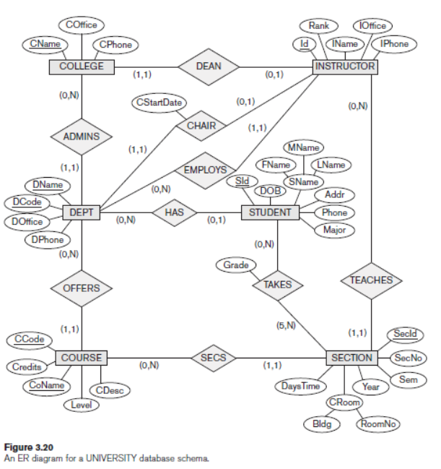

**Airline Database Schema**

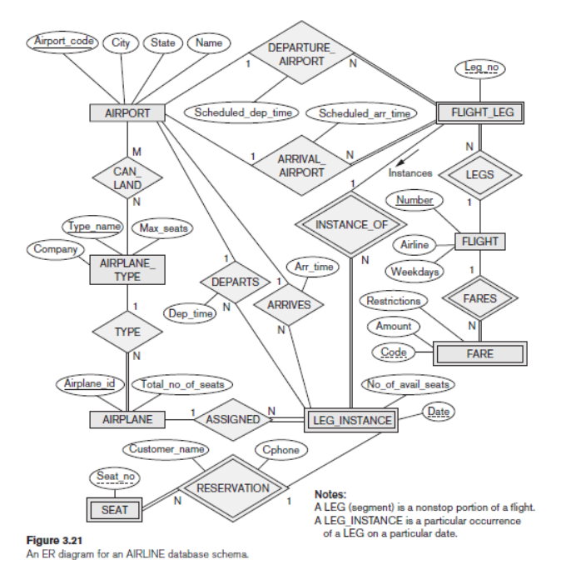

**Company Database Schema**

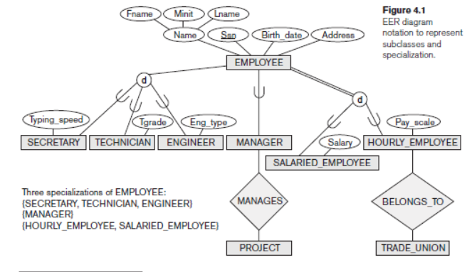

**University-2 Database Schema**

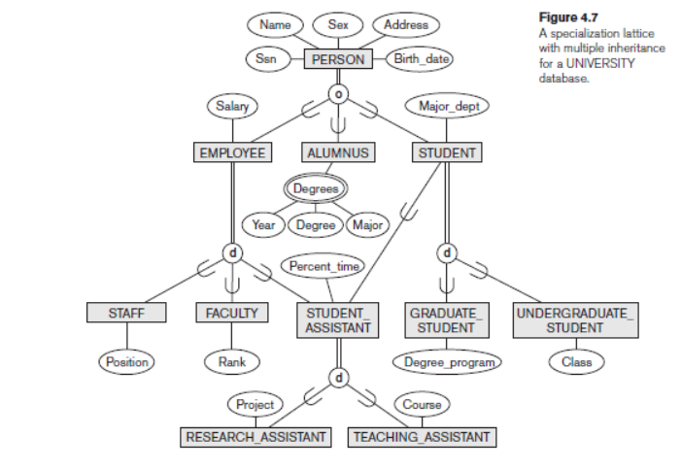

For this EER diagram, you need to suggest attributes for entities that do not have ones. You may also add entities that will enhance the functions of this EER diagram.